Template Driven Forms
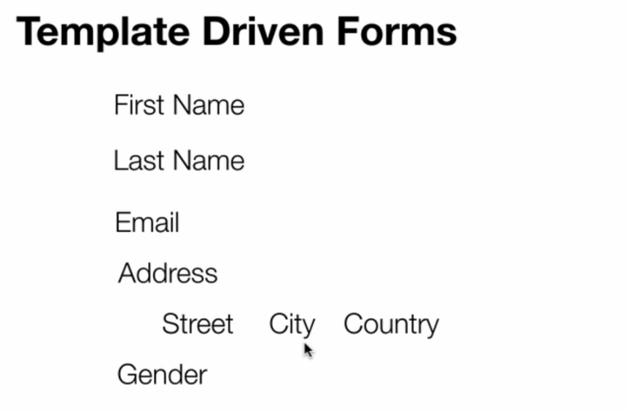

- Import FormsModule : import { FormsModule } from '@angular/forms';
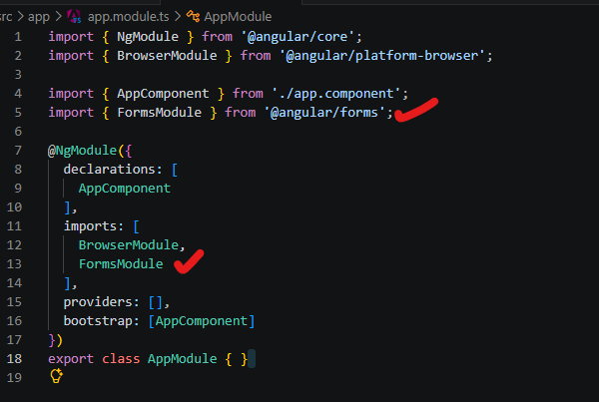

- HTML

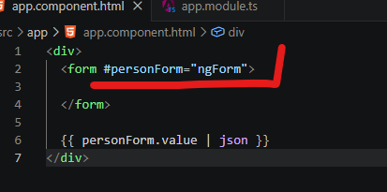

- step create object formGroup object

- To Create form object: #personForm="ngForm" the same as model driven form it will create the object

ស្មើរ នឹងខាងក្រោម ៖
- public personForm!:FormGroup;
- personForm = new FormGroup({})

- Create FromControlName : is the field type for the from

<div>
<label>First Name</label>
<input type="text" name="firstName" ngModel>
</div>

- name is the directive that means the name field.
- ngModel : binding the the name field to the model
- <input type="text" name="lastName" ngModel> == lastName: new FormControl(),

- Add Sub FormGroup fields
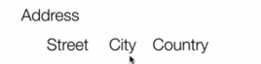

<div ngModelGroup="address">

</div>
វាស្មើរនឹង address: new FormGroup({})
- ngModelGroup = FormGroup = យើងគិតវាដូចជា container ចឹងដែលយើងធ្វើការដាក់ field inside
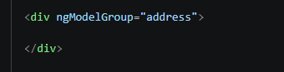

3-1. add sub field to the FormGroup
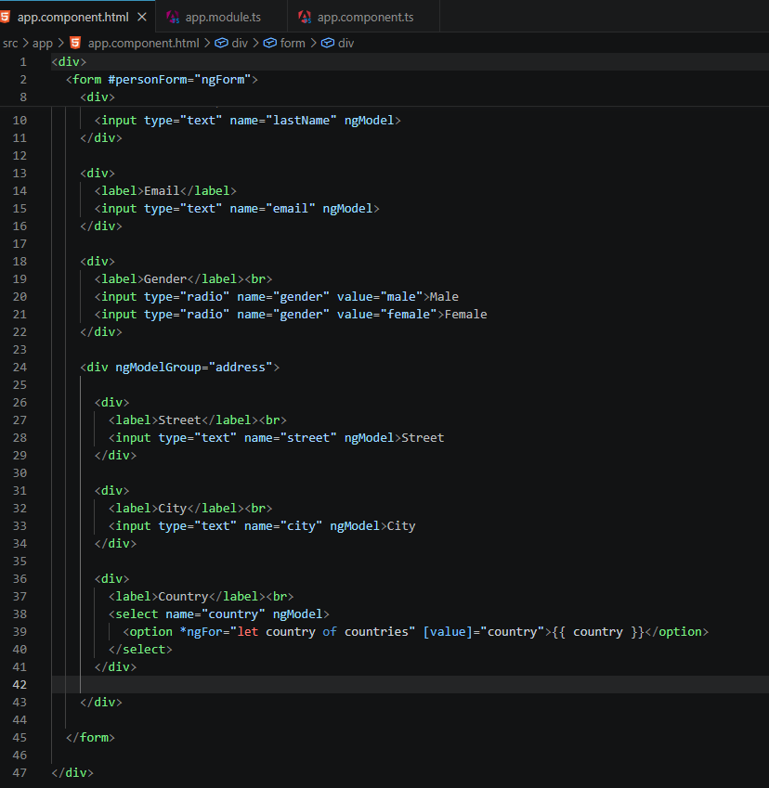

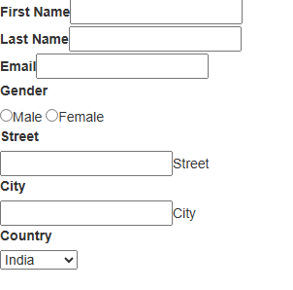

- handle submit form
<form #personForm="ngForm" (ngSubmit)="onSubmit(personForm.value)">

- (ngSubmit)="onSubmit(personForm.value) យើងធ្វើការ submit event from the personForm.value : it sent the JSON file
- personForm.value​ : it will return entire object to the

<div>
<form #personForm="ngForm" (ngSubmit)="onSubmit(personForm.value)">

// button submit:

<div>
<button type="submit" value="Submit">Submit</button>
</div>

</form>
</div>

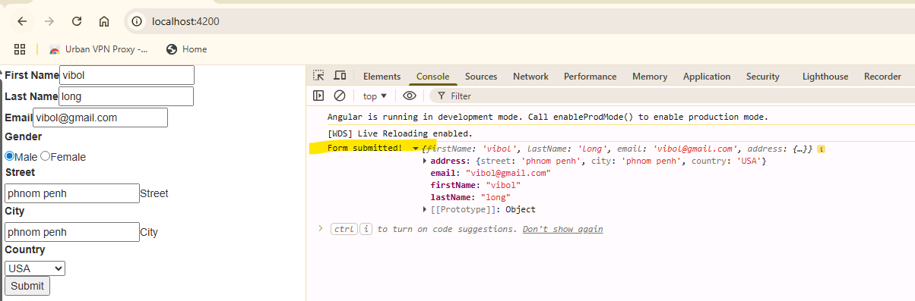

II. Two-Way Binding

- យើងចង់បង្ហាញ តម្លៃ ទៅ Template and from Template to the field (pre populate from model to field) :

Public firstName:string=”Jonh”

<div>
<label>First Name</label>
<input type="text" name="firstName" [(ngModel)]="firstName">
</div>

- [(ngModel)]="firstName" = binding from ngModel to the field name
